04-03-2010
George K. Aidoo
SM/SMS/09/0019
Physics Practical

Experiment 7

Refraction of Light

AIM:

The aim of this experiment is to determine the focal length of a converging lens.

APPARATUS:

Illuminated object (1), screen S (1), converging lens L (1), optical bench (1), lens holder (1), meter rule (1).

DIAGRAM:

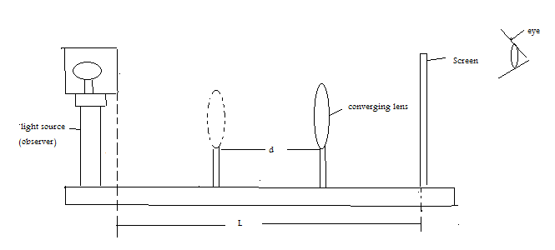

THEORY:

The focal length f of a converging lens may be obtained from the lens formula as:
f = l² – d²/4l and also l² – d² = 4fl.

PROCEDURE:

The approximate focal length f was obtained and recorded by focusing the image of a tree outside the lab on a screen. After obtaining the focal length, the illuminated object and screen were set apart at a length of more than 4 times the length of the focus. The lens was placed near the screen until a sharp image was focused. This distance was noted and recorded as position y. The lens was then moved away from the screen until a sharp magnified image was focused, and this position was recorded as x. The difference between positions x and y gave the displacement d. Five other values of l were used and the process was repeated. L², d², and l²-d² were calculated and recorded for each length measured.

TABLE OF RESULTS (observations):

l²-d² / m² | d² / m² | L² / m² | D / m | Y / m | X / m | L / m
0.7039 | 0.0361 | 0.740 | 0.19 | 0.334 | 0.524 | 0.86
0.7216 | 0.0533 | 0.775 | 0.231 | 0.330 | 0.561 | 0.88
0.7310 | 0.0790 | 0.810 | 0.281 | 0.304 | 0.585 | 0.90
0.7487 | 0.0973 | 0.846 | 0.312 | 0.300 | 0.612 | 0.92
0.7640 | 0.0120 | 0.884 | 0.345 | 0.296 | 0.640 | 0.94

Graph of l²-d² against l:

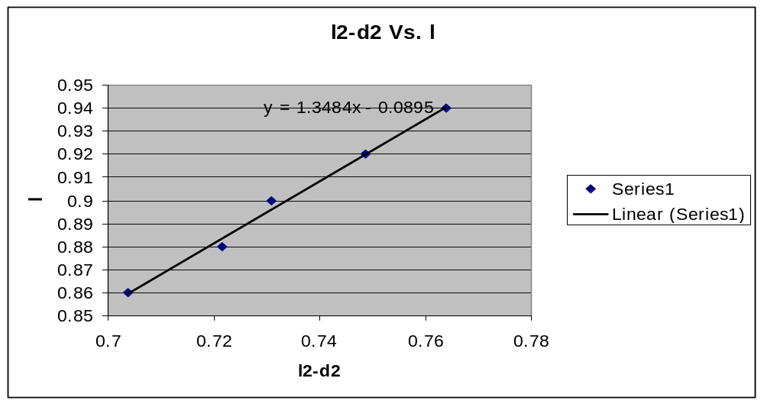

The focal length of the lens, from the slope of the line in the graph above is:
4f = 1.3484
F = 1.3484 / 4
F = 0.3371m

DISCUSSION:

The focus point refers to the point at which incident parallel rays come to a focus after a reflection from the surface of the mirror. The focal length is the distance from the mirror to the focal point. Because the focal length was determined using the image reflected by a converging lens in this experiment, it was appropriate to determine its length mathematically using a scatter diagram. From the graph, the focal length was determined to be 0.3371m. It must be noted that this is only an approximation of the focal length because after finding the focus, the mirror was placed at a distance more than 4 times that focal point.

SOURCES OF ERRORS:

- Determination of the focal point may have been subject to errors due to inaccurate determination of the sharpness of the image used.

PRECAUTIONS:

- Measurements of the displacement were taken more than once to ensure that errors were avoided in the experiment.

CONCLUSION:

The aim of this experiment to determine the focal length of a converging lens was achieved and the focal length was determined to be 0.3371m. The experiment was successful.

REFERENCES:

SERWAY, Raymond A., College Physics/Raymond A. Serway, Jerry S. Faughn, - 6th edition, Pacific Groove, CA 93950. USA. Pg. 412-413

Dr. Anane, University of Cape Coast; School of Medical Sciences, Lecture notes; 22-02-2010.

